**C Graphics**

**line() Function**

* Function line is used to draw a line between two specified points.
* its format is:

line(int x1, int y1, int x2, int y2);

where int x1 and int y1 is starting point and int x2 and y2 is ending point of line, it will draw a line from x1, y1 to x2, y2;

Normally the maximum distance of x is 640, and y is 480.

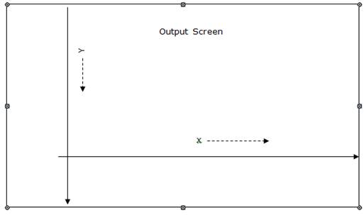

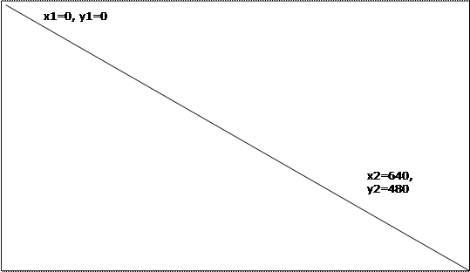

**C Graphic Functions:**

**setfillstyle( int pattern, int color );**

**setbkcolor(int color)**

**Pattern list Color List**

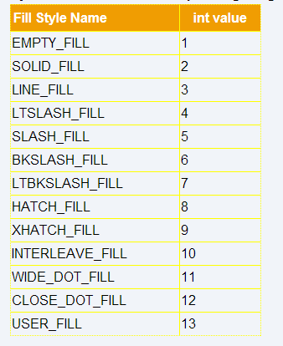 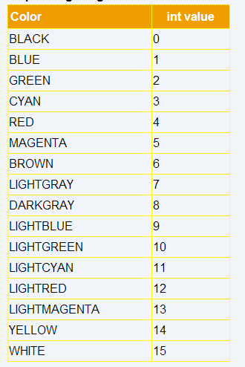

**Example: Draw a polygon and fill the color.**

#include <graphics.h>

#include <stdio.h>

int main( )

{

int points[]={100,150,300,150,300,400,250,400,100,150};

setfillstyle(6,1);

fillpoly(5,points);

getch();

closegraph();

return 0;

}

**Example: Draw a Animated Circles**

#include<stdio.h>

#include<conio.h>

#include<graphics.h>

int main()

{

initwindow(800,600);

int x,y,i;

cleardevice();

x=getmaxx()/2;

y=getmaxy()/2;

settextstyle(TRIPLEX_FONT, HORIZ_DIR, 3);

setbkcolor(rand());

setcolor(4);

outtextxy(30,100,"Press");

outtextxy(30,130,"any");

outtextxy(30,160,"key");

outtextxy(30,190, "to");

outtextxy(30,220,"Quit");

while (!kbhit())

{

setcolor(rand());

for (int i=0;i<50;i++)

circle(x,y,i );

setcolor(rand());

for (int j=70;j<120;j++)

circle(x,y,j);

setcolor(rand());

for (int k=140;k<190;k++)

circle(x,y,k);

setcolor(rand());

for (int l=210;l<230;l++)

circle(x,y,l);

delay(200);

}

getch();

closegraph();

return 0;

}